Artificial Intelligence Techniques for Landslide Prediction Using Satellite Imagery
OBJECTIVE
The main objective of this research is to develop and evaluate Artificial Intelligence (AI)-based models for the prediction and early detection of landslides using satellite imagery. The goal is to enhance the accuracy, timeliness, and reliability of landslide prediction by leveraging machine learning and deep learning techniques that can analyze large-scale spatial and temporal data.
Specific objectives include:
- To collect and preprocess multispectral and temporal satellite imagery from relevant sources (e.g., Sentinel, Landsat) for landslide-prone regions.
- To extract key geospatial and environmental features influencing landslides, such as slope, soil type, vegetation cover, rainfall, and land-use changes.
- To design and implement AI-based models (e.g., Convolutional Neural Networks, Random Forest, or hybrid deep learning architectures) for landslide prediction and risk mapping.
- To evaluate and compare the performance of different AI algorithms in terms of accuracy, precision, recall, and spatial prediction reliability.
- To develop a predictive framework that supports early warning systems and disaster management through automated landslide detection using satellite data.
PROBLEM STATEMENT
Landslides are among the most destructive natural disasters, causing severe damage to infrastructure, the environment, and human lives. Timely and accurate prediction of landslides is crucial for disaster prevention and risk mitigation. However, traditional prediction approaches—based on field surveys, empirical models, or statistical analysis—are often time-consuming, region-specific, and limited in their ability to capture complex nonlinear relationships among multiple environmental factors.
The increasing availability of high-resolution satellite imagery provides valuable spatial and temporal data for landslide monitoring. Yet, manual interpretation of such data is inefficient and prone to human error. Traditional analytical methods struggle to process and learn from the vast amount of geospatial data effectively.
Recent advances in Artificial Intelligence (AI), particularly machine learning and deep learning, offer new opportunities for automated feature extraction and pattern recognition from satellite imagery. However, challenges remain in integrating multisource data, reducing false predictions, and ensuring model generalization across diverse terrains and climatic conditions.
Therefore, there is a pressing need to develop robust, AI-driven predictive models capable of learning complex spatial-temporal relationships from satellite imagery to accurately predict landslide occurrences. Such models can significantly improve early warning systems, assist in risk assessment, and support sustainable land management and disaster preparedness efforts.

Abstract
Landslides are among the most destructive natural disasters, causing severe damage to life, property, and infrastructure across the globe. Early prediction and risk assessment are crucial for reducing their impact. Traditional methods of landslide detection and prediction rely heavily on manual surveys, geological mapping, and rainfall measurements, which are time-consuming and limited in accuracy. With the advancement of remote sensing technology and artificial intelligence (AI), satellite imagery has emerged as a valuable data source for analyzing terrain instability and identifying potential landslide-prone areas. AI techniques such as Machine Learning (ML) and Deep Learning (DL) models—like Convolutional Neural Networks (CNNs), Random Forests, and Support Vector Machines (SVMs)—can automatically extract patterns from large-scale satellite images, correlating features like slope, soil moisture, vegetation index, and rainfall intensity. By integrating multispectral, temporal, and topographical data, these systems can effectively predict high-risk zones with improved precision and efficiency. This approach enables continuous monitoring of vast and inaccessible areas, significantly reducing the need for manual intervention. The proposed system aims to develop a robust AI-based landslide prediction model that leverages real-time satellite data and intelligent algorithms to alert authorities and local communities in advance. Such predictive systems not only enhance disaster preparedness but also contribute to sustainable land-use planning and environmental protection.

Introduction
Landslides are one of the most frequent and devastating natural disasters, leading to significant loss of life, destruction of property, and disruption of the environment. Predicting landslides accurately has always been a challenge due to the complex interactions between geological, hydrological, and environmental factors. Traditional prediction methods rely on field observations, rainfall thresholds, and empirical models, which are often limited in spatial coverage and accuracy. With the advancement of Artificial Intelligence (AI) and satellite remote sensing, researchers are now able to analyze vast amounts of spatial and temporal data to detect early signs of slope instability. AI techniques, especially Machine Learning (ML) and Deep Learning (DL), can process high-resolution satellite imagery to identify critical features such as soil moisture, slope angle, vegetation index, and rainfall intensity, which influence landslide occurrences. Integrating AI algorithms with satellite data provides a powerful framework for real-time monitoring and forecasting, enabling proactive disaster management. The goal of this study is to develop a robust AI-based system capable of predicting landslides accurately using multispectral satellite images, thereby minimizing human and economic losses while enhancing environmental sustainability.
Literature Survey
1. Pradhan, B., & Lee, S. (2019) – “Landslide Susceptibility Mapping Using Machine Learning Algorithms”
In this study, Pradhan and Lee (2019) explored the application of machine learning algorithms such as Random Forest (RF) and Support Vector Machine (SVM) for landslide susceptibility mapping. The research utilized topographic, geological, and rainfall data to identify regions at high risk of landslides. The authors compared the performance of these AI models against traditional statistical techniques and found that machine learning approaches achieved higher predictive accuracy and reliability. The study demonstrated the potential of AI to process large datasets efficiently and produce more precise hazard maps, thus improving the accuracy of landslide risk assessments and early warning systems.

2. Pourghasemi, H. R., & Rossi, M. (2020) – “Advances in Machine Learning for Landslide Susceptibility Assessment Using Remote Sensing Data”
Pourghasemi and Rossi (2020) presented a comprehensive study combining remote sensing imagery and Geographic Information System (GIS) data with advanced machine learning methods to improve landslide susceptibility assessment. Their approach integrated environmental parameters such as NDVI (Normalized Difference Vegetation Index), slope gradient, soil type, and rainfall intensity to create a more accurate and dynamic landslide prediction model. The study highlighted the advantages of using AI techniques in analyzing complex terrain and climatic interactions, allowing for real-time monitoring and automated prediction. Their model proved to be efficient, adaptable, and capable of identifying vulnerable zones with remarkable precision.

3. Hong, H., Pourghasemi, H. R., & Liu, J. (2021) – “Deep Learning Techniques for Landslide Prediction Using Multisource Data”
Hong, Pourghasemi, and Liu (2021) focused on implementing deep learning techniques, particularly Convolutional Neural Networks (CNNs), for landslide prediction using multispectral satellite data. Their research emphasized the capacity of CNNs to automatically extract spatial and temporal patterns from complex satellite images, significantly improving the detection of landslide-prone areas. The study utilized diverse data sources, including topographical, hydrological, and meteorological features, to train the model. The results demonstrated that CNN-based systems could outperform traditional ML models in both accuracy and processing efficiency, providing a solid foundation for real-time, data-driven disaster management.

4. Wang, Y., Chen, W., & Li, X. (2022) – “Integration of Satellite Imagery and Artificial Intelligence for Natural Disaster Prediction”
Wang, Chen, and Li (2022) proposed an innovative AI framework that integrates high-resolution satellite imagery with advanced deep learning algorithms to predict natural disasters, including landslides. The study employed a combination of image processing techniques and neural networks to analyze spatial changes in terrain and vegetation cover. The authors emphasized the benefits of cloud-based processing for handling large-scale geospatial datasets and generating rapid predictions. Their system proved effective in providing near real-time alerts and visual risk assessments, showcasing the role of AI and satellite data fusion in enhancing the speed and scalability of disaster prediction models.

5. Sarkar, S., & Kanungo, D. P. (2023) – “AI-Driven Approaches for Landslide Hazard Assessment: A Review”
Sarkar and Kanungo (2023) conducted a detailed review of existing AI-driven models used for landslide hazard assessment. Their paper analyzed various approaches involving machine learning, deep learning, and hybrid AI-GIS techniques for mapping and predicting landslides. The authors concluded that hybrid models—combining algorithms such as Random Forests, CNNs, and Gradient Boosting—provided the most reliable results by capturing complex, nonlinear relationships between environmental variables. The review also emphasized the importance of incorporating real-time satellite data, IoT sensors, and big data analytics to build robust, adaptive systems. Their findings underline AI’s growing role in the future of intelligent disaster prediction and mitigation strategies.

Existing System
The existing systems for landslide prediction primarily depend on manual observation, field surveys, and statistical models that use limited geotechnical and meteorological data. These traditional approaches are often restricted to small geographical areas and require extensive manpower and time for data collection and analysis. Moreover, they fail to capture real-time changes in terrain conditions such as soil saturation, vegetation cover, and slope movement. Geographic Information Systems (GIS) and basic remote sensing have improved data visualization but still lack the intelligence needed to interpret complex environmental interactions. As a result, predictions generated by conventional models are often inaccurate or delayed, leading to inadequate warning systems and insufficient preventive measures.

Disadvantages of Existing System
- Requires extensive manual labor and field data collection.
- Limited scalability for large or remote regions.
- Inability to process real-time environmental and satellite data effectively.
- Low prediction accuracy due to static and outdated datasets.
- Poor adaptability to varying geological conditions and dynamic climate patterns.

Proposed System
The proposed system introduces an AI-driven landslide prediction framework that utilizes satellite imagery and advanced machine learning techniques for automated analysis. The system collects real-time data from multiple satellite sources, processes it using feature extraction methods, and applies deep learning models such as CNNs to identify potential landslide zones. It integrates parameters such as slope gradient, soil moisture, rainfall intensity, and vegetation index to enhance prediction accuracy. The proposed architecture supports cloud-based data storage and model training for efficient computation and continuous improvement. By leveraging artificial intelligence, the system not only reduces manual intervention but also ensures timely alerts to minimize casualties and infrastructure damage. This modern solution combines satellite technology, AI analytics, and automated risk assessment to deliver a reliable, scalable, and proactive disaster management tool.

Advantages of Proposed System
- High accuracy and reliability through AI-based predictive models.
- Real-time analysis and continuous monitoring using satellite imagery.
- Scalable and automated system requiring minimal human intervention.

System Architecture
The system architecture for AI-based landslide prediction using satellite imagery consists of several key modules. The first module is the Data Acquisition Layer, where high-resolution satellite images and environmental data (such as rainfall, soil moisture, and topography) are collected from multiple remote sensing sources. The Preprocessing Layer performs image enhancement, noise removal, and normalization to prepare the data for analysis. The Feature Extraction Layer identifies critical parameters like slope angle, vegetation index (NDVI), and terrain texture. These features are then fed into the Machine Learning and Deep Learning Layer, where algorithms such as CNNs and Random Forest models analyze spatial and temporal patterns to predict potential landslide zones. The Prediction and Alert Module visualizes risk areas through GIS mapping and generates automated alerts to concerned authorities. Finally, the Database and Cloud Storage Layer manages large datasets and ensures efficient retrieval and model updates for continuous learning and accuracy improvement.

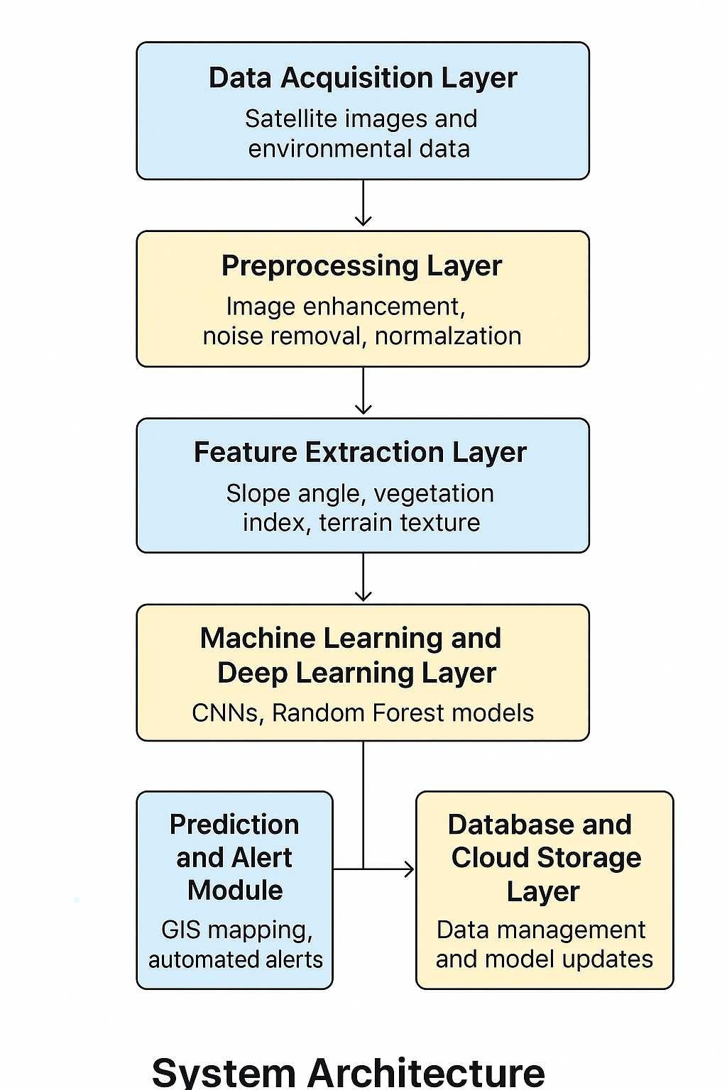
SYSTEM REQUIREMENTS:

HARDWARE REQUIREMENTS:

• System : Pentium IV 2.4 GHz.
• Hard Disk : 40 GB.
• Ram : 512 Mb.

SOFTWARE REQUIREMENTS:

• Operating system : - Windows.
• Coding Language : python.

UML Diagrams:

CLASS DIAGRAM:
The class diagram is used to refine the use case diagram and define a detailed design of the system. The class diagram classifies the actors defined in the use case diagram into a set of interrelated classes. The relationship or association between the classes can be either an "is-a" or "has-a" relationship. Each class in the class diagram may be capable of providing certain functionalities. These functionalities provided by the class are termed "methods" of the class. Apart from this, each class may have certain "attributes" that uniquely.

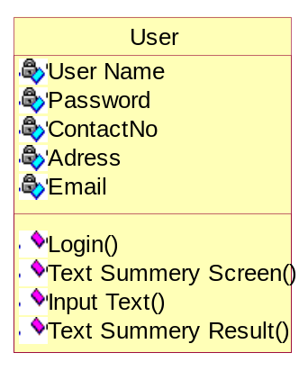

Use case Diagram:
A use case diagram in the Unified Modeling Language (UML) is a type of behavioral diagram defined by and created from a Use-case analysis. Its purpose is to present a graphical overview of the functionality provided by a system in terms of actors, their goals (represented as use cases), and any dependencies between those use cases. The main purpose of a use case diagram is to show what system functions are performed for which actor. Roles of the actors in the system can be depicted.

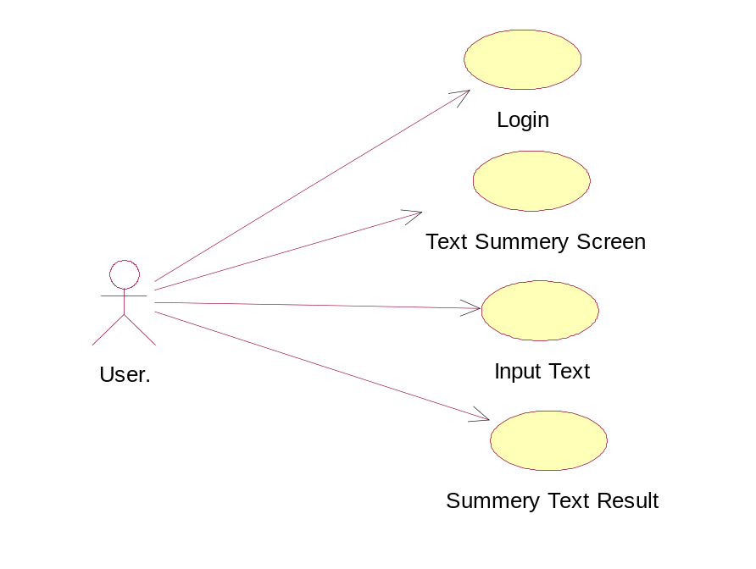

Sequence Diagram:
A sequence diagram represents the interaction between different objects in the system. The important aspect of a sequence diagram is that it is time-ordered. This means that the exact sequence of the interactions between the objects is represented step by step. Different objects in the sequence diagram interact with each other by passing "messages".

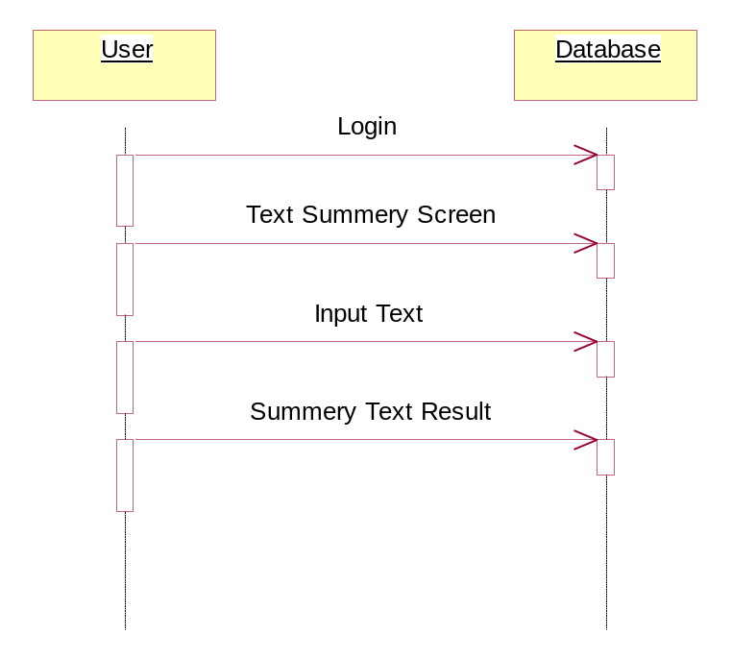

Collaborative Diagram:

A collaboration diagram groups together the interactions between different objects. The interactions are listed as numbered interactions that help to trace the sequence of the interactions. The collaboration diagram helps to identify all the possible interactions that each object has with other objects.
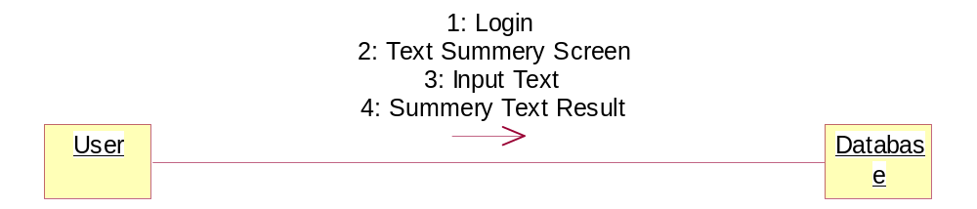

Activity Diagram:
An activity diagram, a type of UML diagram, visually represents the flow of control or activities within a system or process, utilizing standardized symbols such as rectangles for activities, diamonds for decision points, and arrows for transitions. It is extensively used in business process modeling to depict workflows and in software engineering to illustrate algorithmic logic or system behavior. Activity diagrams consist of activities representing actions or steps, transitions indicating the flow between activities, decision points for branching based on conditions, and start and end nodes marking the beginning and conclusion of the process. They offer clarity in understanding and communicating complex processes, aiding in analysis, optimization, and documentation, thus serving as essential tools for both business and software development contexts.

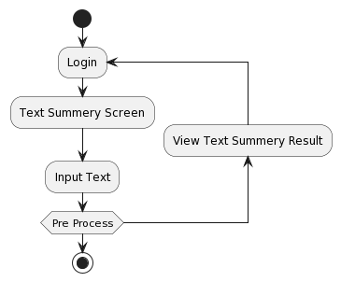
System Implementations:

- Data Preprocessing: Prepare the textual data by removing noise, such as special characters, punctuation, and stopwords. Tokenize the text into sentences or paragraphs to facilitate sentiment analysis and summarization.
- Sentiment Analysis Model: Implement or utilize pre-trained sentiment analysis models capable of accurately detecting the sentiment polarity (positive, negative, neutral) of each sentence or paragraph in the text. Consider employing advanced techniques such as deep learning-based models or transformer architectures for improved accuracy.
- Summarization Model: Implement a text summarization model capable of generating concise summaries while incorporating sentiment information. Explore both extractive and abstractive summarization techniques, considering factors such as coherence, informativeness, and sentiment preservation.
- Integration: Integrate the sentiment analysis module with the summarization module to leverage sentiment information during the summarization process. Design mechanisms to prioritize or adjust the inclusion of sentences based on their sentiment polarity to ensure that the generated summaries reflect the emotional context of the original text.
- Evaluation: Evaluate the performance of the implemented system using standard metrics such as ROUGE (Recall-Oriented Understudy for Gisting Evaluation) for summarization quality and sentiment classification accuracy metrics for sentiment analysis. Conduct thorough evaluations using benchmark datasets to assess the effectiveness and robustness of the system.
- Optimization: Optimize the system for efficiency and scalability by leveraging techniques such as parallel processing, caching, and model compression. Consider deploying the system on distributed computing frameworks or utilizing hardware accelerators (e.g., GPUs) to improve processing speed and resource utilization.
- User Interface: Develop a user-friendly interface for interacting with the system, allowing users to input text and view the generated summaries along with sentiment analysis results. Design the interface to be intuitive, responsive, and accessible across different devices and platforms.
- Deployment: Deploy the implemented system in production environments, considering factors such as scalability, reliability, and security. Ensure proper monitoring and maintenance procedures are in place to address potential issues and ensure continuous performance optimization.
- Feedback Loop: Establish a feedback loop to gather user feedback and monitor system performance over time. Use feedback to iteratively improve the system's accuracy, usability, and effectiveness based on user requirements and evolving needs.

System Environment:

What is Python :-
Below are some facts about Python.
Python is currently the most widely used multi-purpose, high-level programming language.
Python allows programming in Object-Oriented and Procedural paradigms. Python programs generally are smaller than other programming languages like Java.
Programmers have to type relatively less and indentation requirement of the language, makes them readable all the time.
Python language is being used by almost all tech-giant companies like – Google, Amazon, Facebook, Instagram, Dropbox, Uber… etc.
The biggest strength of Python is huge collection of standard library which can be used for the following .
  - Machine Learning
  - GUI Applications (like Kivy, Tkinter, PyQt etc. )
  - Web frameworks like Django (used by YouTube, Instagram, Dropbox)
  - Image processing (like Opencv, Pillow)
  - Web scraping (like Scrapy, BeautifulSoup, Selenium)
  - Test frameworks
  - Multimedia

Advantages of Python :-
Let’s see how Python dominates over other languages.

1. Extensive Libraries
Python downloads with an extensive library and it contain code for various purposes like regular expressions, documentation-generation, unit-testing, web browsers, threading, databases, CGI, email, image manipulation, and more. So, we don’t have to write the complete code for that manually.

2. Extensible
As we have seen earlier, Python can be extended to other languages. You can write some of your code in languages like C++ or C. This comes in handy, especially in projects.

3. Embeddable
Complimentary to extensibility, Python is embeddable as well. You can put your Python code in your source code of a different language, like C++. This lets us add scripting capabilities to our code in the other language.

4. Improved Productivity
The language’s simplicity and extensive libraries render programmers more productive than languages like Java and C++ do. Also, the fact that you need to write less and get more things done.

5. IOT Opportunities
Since Python forms the basis of new platforms like Raspberry Pi, it finds the future bright for the Internet Of Things. This is a way to connect the language with the real world.

6. Simple and Easy
When working with Java, you may have to create a class to print ‘Hello World’. But in Python, just a print statement will do. It is also quite easy to learn, understand, and code. This is why when people pick up Python, they have a hard time adjusting to other more verbose languages like Java.

7. Readable
Because it is not such a verbose language, reading Python is much like reading English. This is the reason why it is so easy to learn, understand, and code. It also does not need curly braces to define blocks, and indentation is mandatory. This further aids the readability of the code.

8. Object-Oriented
This language supports both the procedural and object-oriented programming paradigms. While functions help us with code reusability, classes and objects let us model the real world. A class allows the encapsulation of data and functions into one.

9. Free and Open-Source
Like we said earlier, Python is freely available. But not only can you download Python for free, but you can also download its source code, make changes to it, and even distribute it. It downloads with an extensive collection of libraries to help you with your tasks.

10. Portable
When you code your project in a language like C++, you may need to make some changes to it if you want to run it on another platform. But it isn’t the same with Python. Here, you need to code only once, and you can run it anywhere. This is called Write Once Run Anywhere (WORA). However, you need to be careful enough not to include any system-dependent features.

11. Interpreted
Lastly, we will say that it is an interpreted language. Since statements are executed one by one, debugging is easier than in compiled languages.
Any doubts till now in the advantages of Python? Mention in the comment section.

Advantages of Python Over Other Languages

1. Less Coding
Almost all of the tasks done in Python requires less coding when the same task is done in other languages. Python also has an awesome standard library support, so you don’t have to search for any third-party libraries to get your job done. This is the reason that many people suggest learning Python to beginners.

2. Affordable
Python is free therefore individuals, small companies or big organizations can leverage the free available resources to build applications. Python is popular and widely used so it gives you better community support.
The 2019 Github annual survey showed us that Python has overtaken Java in the most popular programming language category.

3. Python is for Everyone
Python code can run on any machine whether it is Linux, Mac or Windows. Programmers need to learn different languages for different jobs but with Python, you can professionally build web apps, perform data analysis and machine learning, automate things, do web scraping and also build games and powerful visualizations. It is an all-rounder programming language.

Disadvantages of Python
So far, we’ve seen why Python is a great choice for your project. But if you choose it, you should be aware of its consequences as well. Let’s now see the downsides of choosing Python over another language.

1. Speed Limitations
We have seen that Python code is executed line by line. But since Python is interpreted, it often results in slow execution. This, however, isn’t a problem unless speed is a focal point for the project. In other words, unless high speed is a requirement, the benefits offered by Python are enough to distract us from its speed limitations.

2. Weak in Mobile Computing and Browsers
While it serves as an excellent server-side language, Python is much rarely seen on the client-side. Besides that, it is rarely ever used to implement smartphone-based applications. One such application is called Carbonnelle.
The reason it is not so famous despite the existence of Brython is that it isn’t that secure.

3. Design Restrictions
As you know, Python is dynamically-typed. This means that you don’t need to declare the type of variable while writing the code. It uses duck-typing. But wait, what’s that? Well, it just means that if it looks like a duck, it must be a duck. While this is easy on the programmers during coding, it can raise run-time errors.

4. Underdeveloped Database Access Layers
Compared to more widely used technologies like JDBC (Java DataBase Connectivity) and ODBC (Open DataBase Connectivity), Python’s database access layers are a bit underdeveloped. Consequently, it is less often applied in huge enterprises.

5. Simple
No, we’re not kidding. Python’s simplicity can indeed be a problem. Take my example. I don’t do Java, I’m more of a Python person. To me, its syntax is so simple that the verbosity of Java code seems unnecessary.
This was all about the Advantages and Disadvantages of Python Programming Language.
History of Python : -

What do the alphabet and the programming language Python have in common? Right, both start with ABC. If we are talking about ABC in the Python context, it's clear that the programming language ABC is meant. ABC is a general-purpose programming language and programming environment, which had been developed in the Netherlands, Amsterdam, at the CWI (Centrum Wiskunde &Informatica). The greatest achievement of ABC was to influence the design of Python.Python was conceptualized in the late 1980s. Guido van Rossum worked that time in a project at the CWI, called Amoeba, a distributed operating system. In an interview with Bill Venners¹, Guido van Rossum said: "In the early 1980s, I worked as an implementer on a team building a language called ABC at Centrum voor Wiskunde en Informatica (CWI).
I don't know how well people know ABC's influence on Python. I try to mention ABC's influence because I'm indebted to everything I learned during that project and to the people who worked on it."Later on in the same Interview, Guido van Rossum continued: "I remembered all my experience and some of my frustration with ABC. I decided to try to design a simple scripting language that possessed some of ABC's better properties, but without its problems. So I started typing. I created a simple virtual machine, a simple parser, and a simple runtime. I made my own version of the various ABC parts that I liked. I created a basic syntax, used indentation for statement grouping instead of curly braces or begin-end blocks, and developed a small number of powerful data types: a hash table (or dictionary, as we call it), a list, strings, and numbers."

What is Machine Learning : -
Before we take a look at the details of various machine learning methods, let's start by looking at what machine learning is, and what it isn't. Machine learning is often categorized as a subfield of artificial intelligence, but I find that categorization can often be misleading at first brush. The study of machine learning certainly arose from research in this context, but in the data science application of machine learning methods, it's more helpful to think of machine learning as a means of building models of data.
Fundamentally, machine learning involves building mathematical models to help understand data. "Learning" enters the fray when we give these models tunable parameters that can be adapted to observed data; in this way the program can be considered to be "learning" from the data.
Once these models have been fit to previously seen data, they can be used to predict and understand aspects of newly observed data. I'll leave to the reader the more philosophical digression regarding the extent to which this type of mathematical, model-based "learning" is similar to the "learning" exhibited by the human brain.Understanding the problem setting in machine learning is essential to using these tools effectively, and so we will start with some broad categorizations of the types of approaches we'll discuss here.
Categories Of Machine Leaning :-
At the most fundamental level, machine learning can be categorized into two main types: supervised learning and unsupervised learning.
Supervised learning involves somehow modeling the relationship between measured features of data and some label associated with the data; once this model is determined, it can be used to apply labels to new, unknown data. This is further subdivided into classification tasks and regression tasks: in classification, the labels are discrete categories, while in regression, the labels are continuous quantities. We will see examples of both types of supervised learning in the following section.

Unsupervised learning involves modeling the features of a dataset without reference to any label, and is often described as "letting the dataset speak for itself." These models include tasks such as clustering and dimensionality reduction.
Clustering algorithms identify distinct groups of data, while dimensionality reduction algorithms search for more succinct representations of the data. We will see examples of both types of unsupervised learning in the following section.

Need for Machine Learning
Human beings, at this moment, are the most intelligent and advanced species on earth because they can think, evaluate and solve complex problems. On the other side, AI is still in its initial stage and haven’t surpassed human intelligence in many aspects. Then the question is that what is the need to make machine learn? The most suitable reason for doing this is, “to make decisions, based on data, with efficiency and scale”.
Lately, organizations are investing heavily in newer technologies like Artificial Intelligence, Machine Learning and Deep Learning to get the key information from data to perform several real-world tasks and solve problems. We can call it data-driven decisions taken by machines, particularly to automate the process. These data-driven decisions can be used, instead of using programing logic, in the problems that cannot be programmed inherently. The fact is that we can’t do without human intelligence, but other aspect is that we all need to solve real-world problems with efficiency at a huge scale. That is why the need for machine learning arises.

Challenges in Machines Learning :-

While Machine Learning is rapidly evolving, making significant strides with cybersecurity and autonomous cars, this segment of AI as whole still has a long way to go. The reason behind is that ML has not been able to overcome number of challenges. The challenges that ML is facing currently are −
Quality of data − Having good-quality data for ML algorithms is one of the biggest challenges. Use of low-quality data leads to the problems related to data preprocessing and feature extraction.
Time-Consuming task − Another challenge faced by ML models is the consumption of time especially for data acquisition, feature extraction and retrieval.
Lack of specialist persons − As ML technology is still in its infancy stage, availability of expert resources is a tough job.
No clear objective for formulating business problems − Having no clear objective and well-defined goal for business problems is another key challenge for ML because this technology is not that mature yet.
Issue of overfitting & underfitting − If the model is overfitting or underfitting, it cannot be represented well for the problem.
Curse of dimensionality − Another challenge ML model faces is too many features of data points. This can be a real hindrance.
Difficulty in deployment − Complexity of the ML model makes it quite difficult to be deployed in real life.

Applications of Machines Learning :-

Machine Learning is the most rapidly growing technology and according to researchers we are in the golden year of AI and ML. It is used to solve many real-world complex problems which cannot be solved with traditional approach. Following are some real-world applications of ML −
- Emotion analysis
- Sentiment analysis
- Error detection and prevention
- Weather forecasting and prediction
- Stock market analysis and forecasting
- Speech synthesis
- Speech recognition
- Customer segmentation
- Object recognition
- Fraud detection
- Fraud prevention
- Recommendation of products to customer in online shopping

How to Start Learning Machine Learning?
Arthur Samuel coined the term “Machine Learning” in 1959 and defined it as a “Field of study that gives computers the capability to learn without being explicitly programmed”.
And that was the beginning of Machine Learning! In modern times, Machine Learning is one of the most popular (if not the most!) career choices. According to Indeed, Machine Learning Engineer Is The Best Job of 2019 with a 344% growth and an average base salary of $146,085 per year.
But there is still a lot of doubt about what exactly is Machine Learning and how to start learning it? So this article deals with the Basics of Machine Learning and also the path you can follow to eventually become a full-fledged Machine Learning Engineer. Now let’s get started!!!

How to start learning ML?
This is a rough roadmap you can follow on your way to becoming an insanely talented Machine Learning Engineer. Of course, you can always modify the steps according to your needs to reach your desired end-goal!

Step 1 – Understand the Prerequisites
In case you are a genius, you could start ML directly but normally, there are some prerequisites that you need to know which include Linear Algebra, Multivariate Calculus, Statistics, and Python. And if you don’t know these, never fear! You don’t need a Ph.D. degree in these topics to get started but you do need a basic understanding.

(a) Learn Linear Algebra and Multivariate Calculus
Both Linear Algebra and Multivariate Calculus are important in Machine Learning. However, the extent to which you need them depends on your role as a data scientist. If you are more focused on application heavy machine learning, then you will not be that heavily focused on maths as there are many common libraries available. But if you want to focus on R&D in Machine Learning, then mastery of Linear Algebra and Multivariate Calculus is very important as you will have to implement many ML algorithms from scratch.

(b) Learn Statistics
Data plays a huge role in Machine Learning. In fact, around 80% of your time as an ML expert will be spent collecting and cleaning data. And statistics is a field that handles the collection, analysis, and presentation of data. So it is no surprise that you need to learn it!!!
Some of the key concepts in statistics that are important are Statistical Significance, Probability Distributions, Hypothesis Testing, Regression, etc. Also, Bayesian Thinking is also a very important part of ML which deals with various concepts like Conditional Probability, Priors, and Posteriors, Maximum Likelihood, etc.

(c) Learn Python
Some people prefer to skip Linear Algebra, Multivariate Calculus and Statistics and learn them as they go along with trial and error. But the one thing that you absolutely cannot skip is Python! While there are other languages you can use for Machine Learning like R, Scala, etc. Python is currently the most popular language for ML. In fact, there are many Python libraries that are specifically useful for Artificial Intelligence and Machine Learning such as Keras, TensorFlow, Scikit-learn, etc.
So if you want to learn ML, it’s best if you learn Python! You can do that using various online resources and courses such as Fork Python available Free on GeeksforGeeks.

Step 2 – Learn Various ML Concepts
Now that you are done with the prerequisites, you can move on to actually learning ML (Which is the fun part!!!) It’s best to start with the basics and then move on to the more complicated stuff. Some of the basic concepts in ML are:

(a) Terminologies of Machine Learning
- Model – A model is a specific representation learned from data by applying some machine learning algorithm. A model is also called a hypothesis.
- Feature – A feature is an individual measurable property of the data. A set of numeric features can be conveniently described by a feature vector. Feature vectors are fed as input to the model. For example, in order to predict a fruit, there may be features like color, smell, taste, etc.
- Target (Label) – A target variable or label is the value to be predicted by our model. For the fruit example discussed in the feature section, the label with each set of input would be the name of the fruit like apple, orange, banana, etc.
- Training – The idea is to give a set of inputs(features) and it’s expected outputs(labels), so after training, we will have a model (hypothesis) that will then map new data to one of the categories trained on.
- Prediction – Once our model is ready, it can be fed a set of inputs to which it will provide a predicted output(label).

(b) Types of Machine Learning
- Supervised Learning – This involves learning from a training dataset with labeled data using classification and regression models. This learning process continues until the required level of performance is achieved.
- Unsupervised Learning – This involves using unlabelled data and then finding the underlying structure in the data in order to learn more and more about the data itself using factor and cluster analysis models.
- Semi-supervised Learning – This involves using unlabelled data like Unsupervised Learning with a small amount of labeled data. Using labeled data vastly increases the learning accuracy and is also more cost-effective than Supervised Learning.
- Reinforcement Learning – This involves learning optimal actions through trial and error. So the next action is decided by learning behaviors that are based on the current state and that will maximize the reward in the future.

Advantages of Machine learning :-

1. Easily identifies trends and patterns -
Machine Learning can review large volumes of data and discover specific trends and patterns that would not be apparent to humans. For instance, for an e-commerce website like Amazon, it serves to understand the browsing behaviors and purchase histories of its users to help cater to the right products, deals, and reminders relevant to them. It uses the results to reveal relevant advertisements to them.

2. No human intervention needed (automation)
With ML, you don’t need to babysit your project every step of the way. Since it means giving machines the ability to learn, it lets them make predictions and also improve the algorithms on their own. A common example of this is anti-virus softwares; they learn to filter new threats as they are recognized. ML is also good at recognizing spam.

3. Continuous Improvement
As ML algorithms gain experience, they keep improving in accuracy and efficiency. This lets them make better decisions. Say you need to make a weather forecast model. As the amount of data you have keeps growing, your algorithms learn to make more accurate predictions faster.

4. Handling multi-dimensional and multi-variety data
Machine Learning algorithms are good at handling data that are multi-dimensional and multi-variety, and they can do this in dynamic or uncertain environments.

5. Wide Applications
You could be an e-tailer or a healthcare provider and make ML work for you. Where it does apply, it holds the capability to help deliver a much more personal experience to customers while also targeting the right customers.

Disadvantages of Machine Learning :-

1. Data Acquisition
Machine Learning requires massive data sets to train on, and these should be inclusive/unbiased, and of good quality. There can also be times where they must wait for new data to be generated.

2. Time and Resources
ML needs enough time to let the algorithms learn and develop enough to fulfill their purpose with a considerable amount of accuracy and relevancy. It also needs massive resources to function. This can mean additional requirements of computer power for you.

3. Interpretation of Results
Another major challenge is the ability to accurately interpret results generated by the algorithms. You must also carefully choose the algorithms for your purpose.

4. High error-susceptibility
Machine Learning is autonomous but highly susceptible to errors. Suppose you train an algorithm with data sets small enough to not be inclusive. You end up with biased predictions coming from a biased training set. This leads to irrelevant advertisements being displayed to customers. In the case of ML, such blunders can set off a chain of errors that can go undetected for long periods of time. And when they do get noticed, it takes quite some time to recognize the source of the issue, and even longer to correct it.

Python Development Steps : -
Guido Van Rossum published the first version of Python code (version 0.9.0) at alt.sources in February 1991. This release included already exception handling, functions, and the core data types of list, dict, str and others. It was also object oriented and had a module system.
Python version 1.0 was released in January 1994. The major new features included in this release were the functional programming tools lambda, map, filter and reduce, which Guido Van Rossum never liked.Six and a half years later in October 2000, Python 2.0 was introduced. This release included list comprehensions, a full garbage collector and it was supporting unicode.Python flourished for another 8 years in the versions 2.x before the next major release as Python 3.0 (also known as "Python 3000" and "Py3K") was released. Python 3 is not backwards compatible with Python 2.x.

The emphasis in Python 3 had been on the removal of duplicate programming constructs and modules, thus fulfilling or coming close to fulfilling the 13th law of the Zen of Python: "There should be one -- and preferably only one -- obvious way to do it."Some changes in Python 7.3:
- Print is now a function
- Views and iterators instead of lists
- The rules for ordering comparisons have been simplified. E.g. a heterogeneous list cannot be sorted, because all the elements of a list must be comparable to each other.
- There is only one integer type left, i.e. int. long is int as well.
- The division of two integers returns a float instead of an integer. "//" can be used to have the "old" behaviour.
- Text Vs. Data Instead Of Unicode Vs. 8-bit
Purpose :-
We demonstrated that our approach enables successful segmentation of intra-retinal layers—even with low-quality images containing speckle noise, low contrast, and different intensity ranges throughout—with the assistance of the ANIS feature.

Python
Python is an interpreted high-level programming language for general-purpose programming. Created by Guido van Rossum and first released in 1991, Python has a design philosophy that emphasizes code readability, notably using significant whitespace.
Python features a dynamic type system and automatic memory management. It supports multiple programming paradigms, including object-oriented, imperative, functional and procedural, and has a large and comprehensive standard library.
- Python is Interpreted − Python is processed at runtime by the interpreter. You do not need to compile your program before executing it. This is similar to PERL and PHP.
- Python is Interactive − you can actually sit at a Python prompt and interact with the interpreter directly to write your programs.
Python also acknowledges that speed of development is important. Readable and terse code is part of this, and so is access to powerful constructs that avoid tedious repetition of code. Maintainability also ties into this may be an all but useless metric, but it does say something about how much code you have to scan, read and/or understand to troubleshoot problems or tweak behaviors. This speed of development, the ease with which a programmer of other languages can pick up basic Python skills and the huge standard library is key to another area where Python excels. All its tools have been quick to implement, saved a lot of time, and several of them have later been patched and updated by people with no Python background - without breaking.

Modules Used in Project :-
Tensorflow
TensorFlow is a free and open-source software library for dataflow and differentiable programming across a range of tasks. It is a symbolic math library, and is also used for machine learning applications such as neural networks. It is used for both research and production at Google.‍
TensorFlow was developed by the Google Brain team for internal Google use. It was released under the Apache 2.0 open-source license on November 9, 2015.
Numpy
Numpy is a general-purpose array-processing package. It provides a high-performance multidimensional array object, and tools for working with these arrays.
It is the fundamental package for scientific computing with Python. It contains various features including these important ones:
- A powerful N-dimensional array object
- Sophisticated (broadcasting) functions
- Tools for integrating C/C++ and Fortran code
- Useful linear algebra, Fourier transform, and random number capabilities
Besides its obvious scientific uses, Numpy can also be used as an efficient multi-dimensional container of generic data. Arbitrary data-types can be defined using Numpy which allows Numpy to seamlessly and speedily integrate with a wide variety of databases.

Pandas
Pandas is an open-source Python Library providing high-performance data manipulation and analysis tool using its powerful data structures. Python was majorly used for data munging and preparation. It had very little contribution towards data analysis. Pandas solved this problem. Using Pandas, we can accomplish five typical steps in the processing and analysis of data, regardless of the origin of data load, prepare, manipulate, model, and analyze. Python with Pandas is used in a wide range of fields including academic and commercial domains including finance, economics, Statistics, analytics, etc.
Matplotlib
Matplotlib is a Python 2D plotting library which produces publication quality figures in a variety of hardcopy formats and interactive environments across platforms. Matplotlib can be used in Python scripts, the Python and IPython shells, the Jupyter Notebook, web application servers, and four graphical user interface toolkits. Matplotlib tries to make easy things easy and hard things possible. You can generate plots, histograms, power spectra, bar charts, error charts, scatter plots, etc., with just a few lines of code. For examples, see the sample plots and thumbnail gallery.
For simple plotting the pyplot module provides a MATLAB-like interface, particularly when combined with IPython. For the power user, you have full control of line styles, font properties, axes properties, etc, via an object oriented interface or via a set of functions familiar to MATLAB users.

Scikit – learn
Scikit-learn provides a range of supervised and unsupervised learning algorithms via a consistent interface in Python. It is licensed under a permissive simplified BSD license and is distributed under many Linux distributions, encouraging academic and commercial use. Python
Python is an interpreted high-level programming language for general-purpose programming. Created by Guido van Rossum and first released in 1991, Python has a design philosophy that emphasizes code readability, notably using significant whitespace.
Python features a dynamic type system and automatic memory management. It supports multiple programming paradigms, including object-oriented, imperative, functional and procedural, and has a large and comprehensive standard library.
- Python is Interpreted − Python is processed at runtime by the interpreter. You do not need to compile your program before executing it. This is similar to PERL and PHP.
- Python is Interactive − you can actually sit at a Python prompt and interact with the interpreter directly to write your programs.
Python also acknowledges that speed of development is important. Readable and terse code is part of this, and so is access to powerful constructs that avoid tedious repetition of code. Maintainability also ties into this may be an all but useless metric, but it does say something about how much code you have to scan, read and/or understand to troubleshoot problems or tweak behaviors. This speed of development, the ease with which a programmer of other languages can pick up basic Python skills and the huge standard library is key to another area where Python excels.
All its tools have been quick to implement, saved a lot of time, and several of them have later been patched and updated by people with no Python background - without breaking.
Install Python Step-by-Step in Windows and Mac :
Python a versatile programming language doesn’t come pre-installed on your computer devices. Python was first released in the year 1991 and until today it is a very popular high-level programming language. Its style philosophy emphasizes code readability with its notable use of great whitespace.
The object-oriented approach and language construct provided by Python enables programmers to write both clear and logical code for projects. This software does not come pre-packaged with Windows.

How to Install Python on Windows and Mac :

There have been several updates in the Python version over the years. The question is how to install Python? It might be confusing for the beginner who is willing to start learning Python but this tutorial will solve your query. The latest or the newest version of Python is version 3.7.4 or in other words, it is Python 3.
Note: The python version 3.7.4 cannot be used on Windows XP or earlier devices.

Before you start with the installation process of Python. First, you need to know about your System Requirements. Based on your system type i.e. operating system and based processor, you must download the python version. My system type is a Windows 64-bit operating system. So the steps below are to install python version 3.7.4 on Windows 7 device or to install Python 3. Download the Python Cheatsheet here.The steps on how to install Python on Windows 10, 8 and 7 are divided into 4 parts to help understand better.

Download the Correct version into the system

Step 1: Go to the official site to download and install python using Google Chrome or any other web browser. OR Click on the following link: https://www.python.org

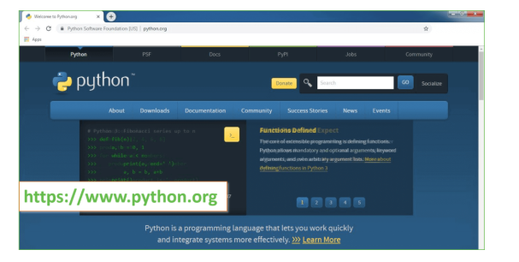
Now, check for the latest and the correct version for your operating system.
Step 2: Click on the Download Tab.
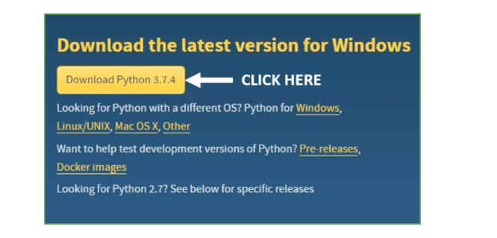
Step 3: You can either select the Download Python for windows 3.7.4 button in Yellow Color or you can scroll further down and click on download with respective to their version. Here, we are downloading the most recent python version for windows 3.7.4
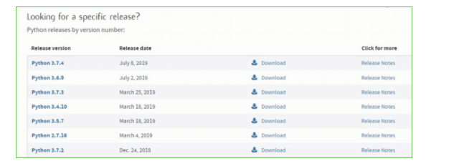
Step 4: Scroll down the page until you find the Files option.

Step 5: Here you see a different version of python along with the operating system.

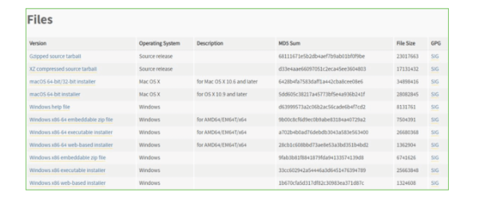

• To download Windows 32-bit python, you can select any one from the three options: Windows x86 embeddable zip file, Windows x86 executable installer or Windows x86 web-based installer.
•To download Windows 64-bit python, you can select any one from the three options: Windows x86-64 embeddable zip file, Windows x86-64 executable installer or Windows x86-64 web-based installer.
Here we will install Windows x86-64 web-based installer. Here your first part regarding which version of python is to be downloaded is completed. Now we move ahead with the second part in installing python i.e. Installation
Note: To know the changes or updates that are made in the version you can click on the Release Note Option.

Installation of Python
Step 1: Go to Download and Open the downloaded python version to carry out the installation process.
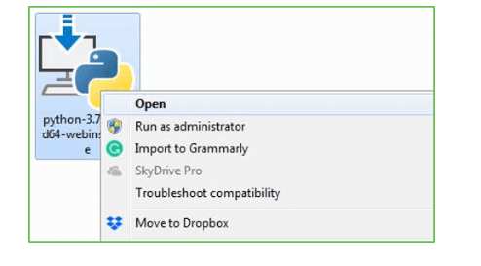
Step 2: Before you click on Install Now, Make sure to put a tick on Add Python 3.7 to PATH.

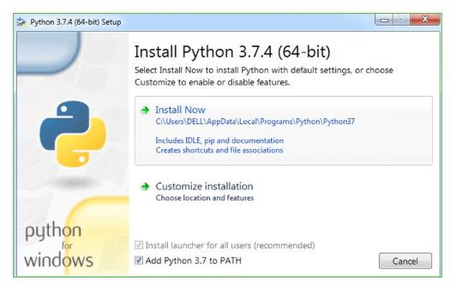

Step 3: Click on Install NOW After the installation is successful. Click on Close.



With these above three steps on python installation, you have successfully and correctly installed Python. Now is the time to verify the installation.
Note: The installation process might take a couple of minutes.

Verify the Python Installation
Step 1: Click on Start
Step 2: In the Windows Run Command, type “cmd”.

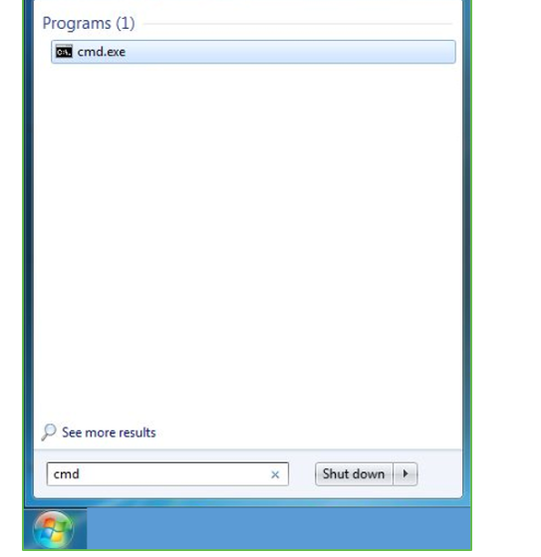
Step 3: Open the Command prompt option.
Step 4: Let us test whether the python is correctly installed. Type python –V and press Enter.

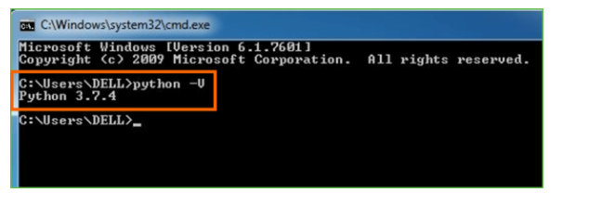
Step 5: You will get the answer as 3.7.4
Note: If you have any of the earlier versions of Python already installed. You must first uninstall the earlier version and then install the new one.

Check how the Python IDLE works
Step 1: Click on Start
Step 2: In the Windows Run command, type “python idle”.
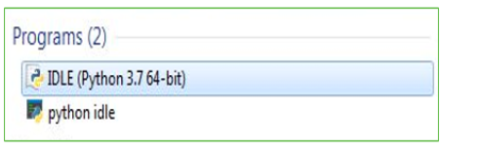
Step 3: Click on IDLE (Python 3.7 64-bit) and launch the program
Step 4: To go ahead with working in IDLE you must first save the file. Click on File > Click on Save

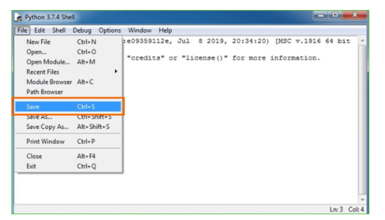
Step 5: Name the file and save as type should be Python files. Click on SAVE. Here I have named the files as Hey World.
Step 6: Now for e.g. enter print

6.SYSTEM TEST
The purpose of testing is to discover errors. Testing is the process of trying to discover every conceivable fault or weakness in a work product. It provides a way to check the functionality of components, sub assemblies, assemblies and/or a finished product It is the process of exercising software with the intent of ensuring that the Software system meets its requirements and user expectations and does not fail in an unacceptable manner. There are various types of test. Each test type addresses a specific testing requirement.

TYPES OF TESTS

Unit testing
Unit testing involves the design of test cases that validate that the internal program logic is functioning properly, and that program inputs produce valid outputs. All decision branches and internal code flow should be validated. It is the testing of individual software units of the application .it is done after the completion of an individual unit before integration. This is a structural testing, that relies on knowledge of its construction and is invasive. Unit tests perform basic tests at component level and test a specific business process, application, and/or system configuration. Unit tests ensure that each unique path of a business process performs accurately to the documented specifications and contains clearly defined inputs and expected results.

Integration testing
Integration tests are designed to test integrated software components to determine if they actually run as one program. Testing is event driven and is more concerned with the basic outcome of screens or fields. Integration tests demonstrate that although the components were individually satisfaction, as shown by successfully unit testing, the combination of components is correct and consistent. Integration testing is specifically aimed at exposing the problems that arise from the combination of components.

Functional test

Functional tests provide systematic demonstrations that functions tested are available as specified by the business and technical requirements, system documentation, and user manuals.
Functional testing is centered on the following items:
Valid Input : identified classes of valid input must be accepted.
Invalid Input : identified classes of invalid input must be rejected.
Functions : identified functions must be exercised.
Output : identified classes of application outputs must be exercised.

Systems/Procedures : interfacing systems or procedures must be invoked.
Organization and preparation of functional tests is focused on requirements, key functions, or special test cases. In addition, systematic coverage pertaining to identify Business process flows; data fields, predefined processes, and successive processes must be considered for testing. Before functional testing is complete, additional tests are identified and the effective value of current tests is determined.

System Test
System testing ensures that the entire integrated software system meets requirements. It tests a configuration to ensure known and predictable results. An example of system testing is the configuration oriented system integration test. System testing is based on process descriptions and flows, emphasizing pre-driven process links and integration points.

White Box Testing
White Box Testing is a testing in which in which the software tester has knowledge of the inner workings, structure and language of the software, or at least its purpose. It is purpose. It is used to test areas that cannot be reached from a black box level.

Black Box Testing

Black Box Testing is testing the software without any knowledge of the inner workings, structure or language of the module being tested. Black box tests, as most other kinds of tests, must be written from a definitive source document, such as specification or requirements document, such as specification or requirements document. It is a testing in which the software under test is treated, as a black box .you cannot “see” into it. The test provides inputs and responds to outputs without considering how the software works.
Unit Testing
Unit testing is usually conducted as part of a combined code and unit test phase of the software lifecycle, although it is not uncommon for coding and unit testing to be conducted as two distinct phases.
Test strategy and approach
Field testing will be performed manually and functional tests will be written in detail.
Test objectives
- All field entries must work properly.
- Pages must be activated from the identified link.
- The entry screen, messages and responses must not be delayed.

Features to be tested
- Verify that the entries are of the correct format
- No duplicate entries should be allowed
- All links should take the user to the correct page.

Integration Testing
Software integration testing is the incremental integration testing of two or more integrated software components on a single platform to produce failures caused by interface defects.
The task of the integration test is to check that components or software applications, e.g. components in a software system or – one step up – software applications at the company level – interact without error.
Test Results: All the test cases mentioned above passed successfully. No defects encountered.

Acceptance Testing
User Acceptance Testing is a critical phase of any project and requires significant participation by the end user. It also ensures that the system meets the functional requirements.
Test Results: All the test cases mentioned above passed successfully. No defects encountered.

Test cases1:
Test case for Login form:

FUNCTION: | LOGIN
EXPECTED RESULTS: | Should Validate the user and check his existence in database
ACTUAL RESULTS: | Validate the user and checking the user against the database
LOW PRIORITY | No
HIGH PRIORITY | Yes

Test case2:
Test case for User Registration form:

FUNCTION: | USER REGISTRATION
EXPECTED RESULTS: | Should check if all the fields are filled by the user and saving the user to database.
ACTUAL RESULTS: | Checking whether all the fields are field by user or not through validations and saving user.
LOW PRIORITY | No
HIGH PRIORITY | Yes

Test case3:
Test case for Change Password:
When the old password does not match with the new password ,then this results in displaying an error message as “ OLD PASSWORD DOES NOT MATCH WITH THE NEW PASSWORD”.
FUNCTION: | Change Password
EXPECTED RESULTS: | Should check if old password and new password fields are filled by the user and saving the user to database.
ACTUAL RESULTS: | Checking whether all the fields are field by user or not through validations and saving user.
LOW PRIORITY | No
HIGH PRIORITY | Yes

Screens:
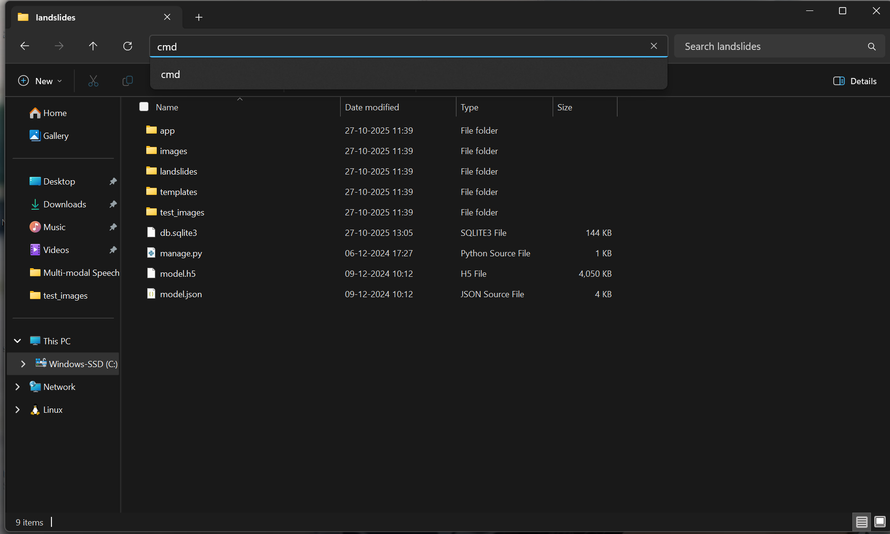

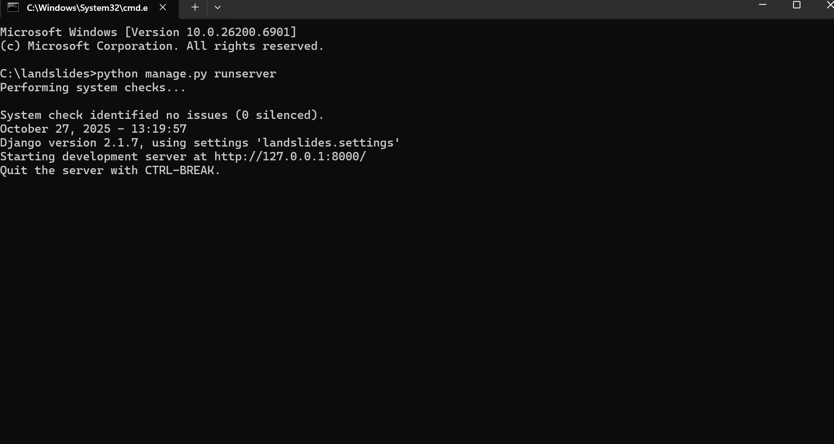
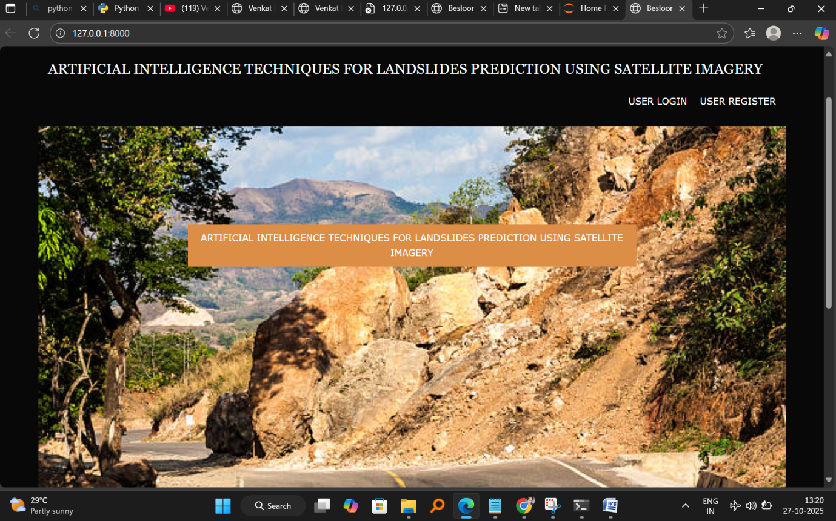
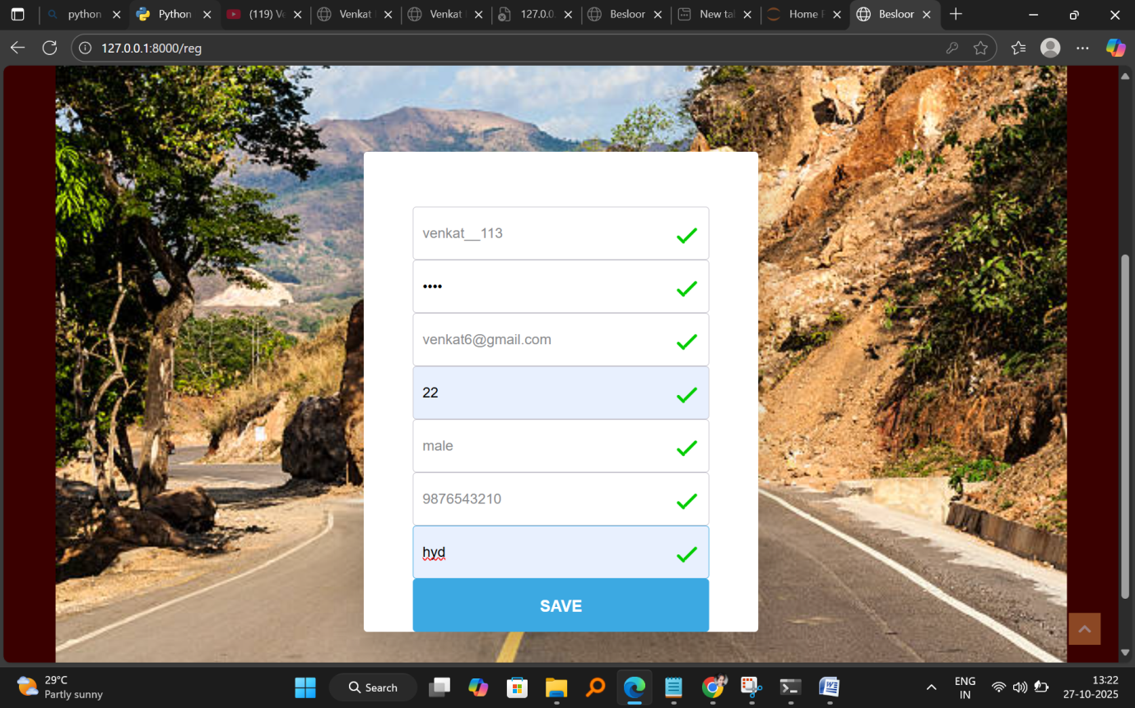
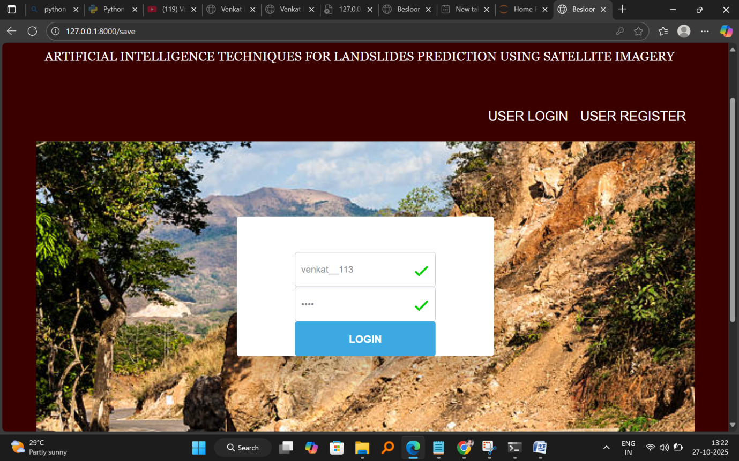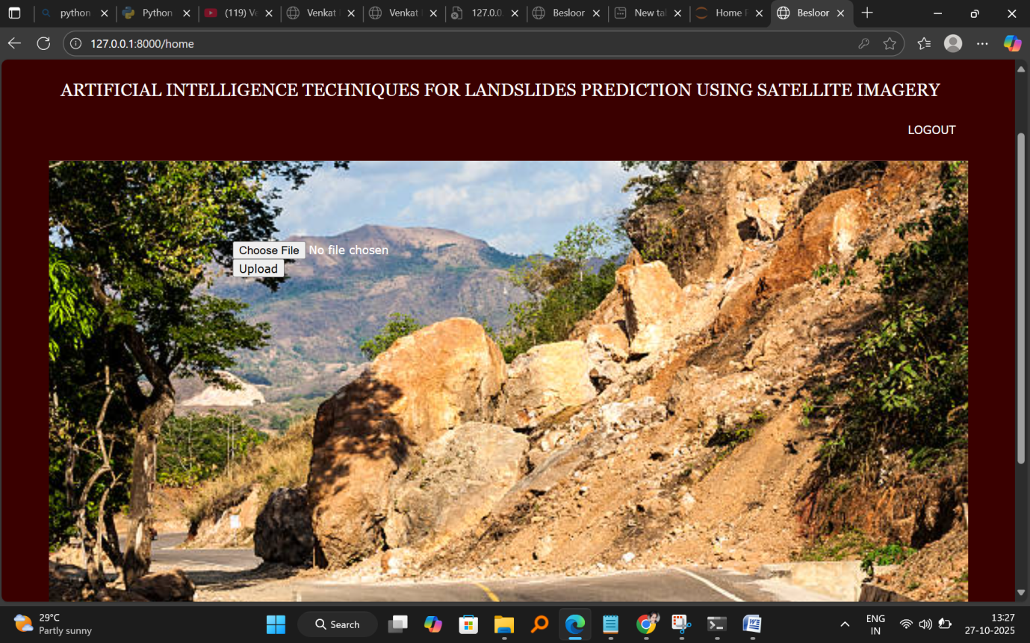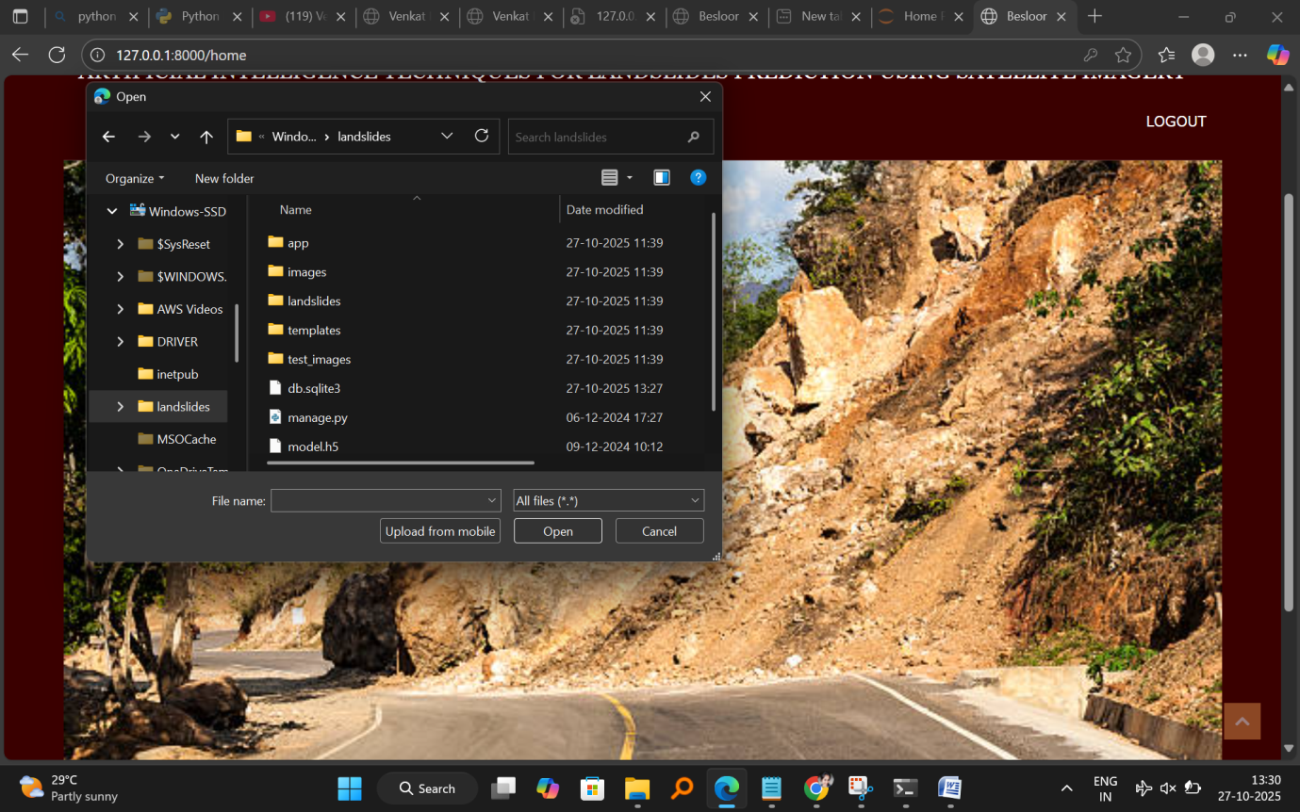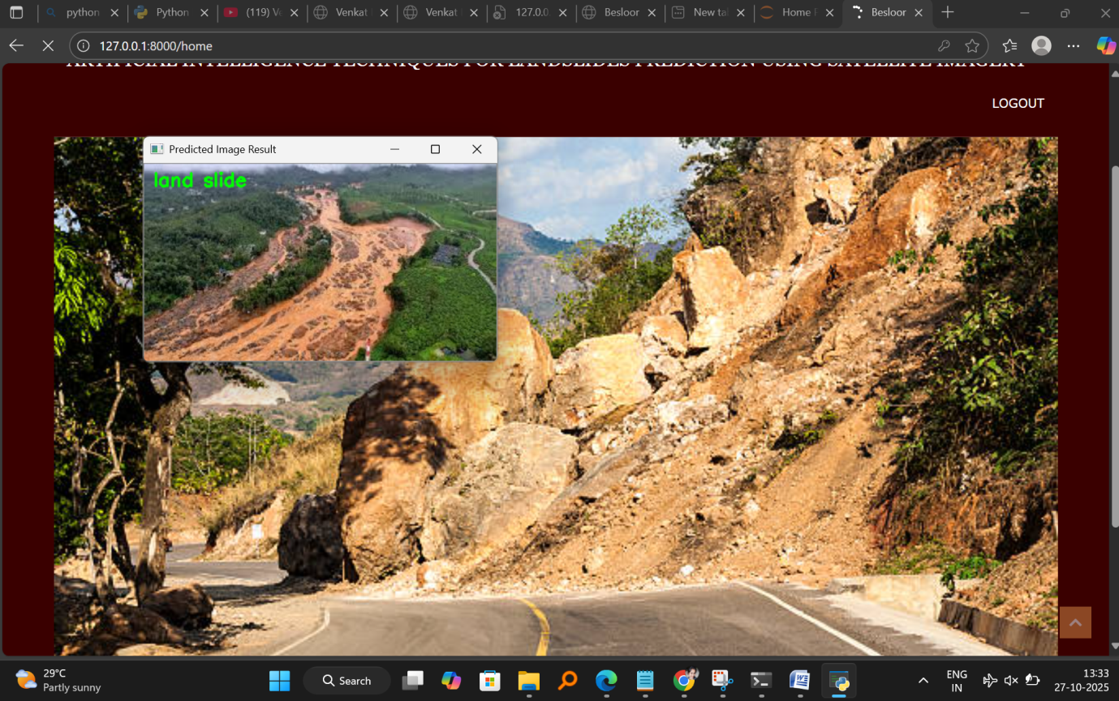

Conclusion:
The AI-based landslide prediction system effectively integrates satellite imagery with advanced machine learning techniques to deliver early and accurate warnings for potential landslide events. By enabling continuous monitoring of terrain conditions and automating risk detection, it significantly strengthens disaster preparedness and response. This intelligent, data-driven approach not only enhances public safety and minimizes damage to life and infrastructure but also supports sustainable land-use planning and long-term environmental protection.
Future Scope
The future scope of AI-based landslide prediction systems lies in enhancing the integration of diverse data sources, such as drone imagery, IoT-based ground sensors, and real-time weather forecasting models. Future models can incorporate hybrid deep learning architectures that combine spatial, temporal, and environmental features for improved prediction accuracy. The use of cloud computing and edge AI can enable faster data processing and near real-time alerts, even in remote areas with limited connectivity. Additionally, integrating blockchain technology can ensure secure data sharing between agencies for coordinated disaster response. Future developments may also focus on creating interactive dashboards and mobile applications to provide accessible alerts and risk maps to local communities and authorities. Expanding the model to a global scale and adapting it to different terrains and climatic zones will further enhance its utility in global disaster management and climate resilience efforts.

References
- Pradhan, B., & Lee, S. (2019). Landslide Susceptibility Mapping Using Machine Learning Algorithms. Springer.
- Pourghasemi, H. R., & Rossi, M. (2020). Advances in Machine Learning for Landslide Susceptibility Assessment Using Remote Sensing Data. Geomatics, Natural Hazards and Risk, 11(1), 228–250.
- Hong, H., Pourghasemi, H. R., & Liu, J. (2021). Deep Learning Techniques for Landslide Prediction Using Multisource Data. Remote Sensing, 13(5), 1–22.
- Wang, Y., Chen, W., & Li, X. (2022). Integration of Satellite Imagery and Artificial Intelligence for Natural Disaster Prediction. IEEE Transactions on Geoscience and Remote Sensing, 60(3), 1–12.
- Sarkar, S., & Kanungo, D. P. (2023). AI-Driven Approaches for Landslide Hazard Assessment: A Review. International Journal of Disaster Risk Reduction, 91, 103600.

